

**Mob App Development**

**Section – A**

**Report**

**Group Members:**

**Hannan Zahid (241545586)**

**Mahnoor Khalid (241555407)**

**Laiba Nusrat (241549070)**

**Project Title:**

**Mobile Application for Color Blindness Testing**

**Introduction:**

Color blindness, or color vision deficiency, is a prevalent visual impairment affecting a significant portion of the global population. Recognizing the importance of early detection and awareness, this project aims to develop a comprehensive mobile application for color blindness testing. The primary objective is to provide a user-friendly platform that allows individuals to self-assess their color vision, facilitating early identification and understanding of color vision deficiencies.

**Objective:**

* **Diagnostic Accuracy:**

Develop a series of scientifically validated color vision tests to accurately assess different types and levels of color blindness.

* **User-Friendly Interface:**

Create an intuitive and easy-to-navigate mobile application interface, ensuring accessibility for users of all ages and technical abilities.

* **Personalized Reports:**

Generate detailed color vision reports for users, offering insights into their specific color blindness type and severity.

**Problem Statement:**

Color blindness often goes undetected until later stages, limiting opportunities for timely intervention and awareness. Existing color blindness tests may not be easily accessible or user-friendly. The need for a mobile application that combines scientific accuracy, user-friendliness, and personalized reporting is evident.

**Literature Review:**

Color blindness, a prevalent visual impairment, has prompted the development of various mobile applications aimed at facilitating self-assessment and awareness. This literature review explores existing color blindness testing apps, including widely recognized ones like the Ishihara test app, EnChroma's offering, and others. It delves into the advantages and limitations of these apps, shedding light on the current landscape and identifying areas for improvement.

**Existing Color Blindness Testing Apps:**

* **Ishihara Test App:**

The Ishihara test, a well-established method for diagnosing color vision deficiencies, has transitioned into mobile applications. The Ishihara test app replicates the traditional test format, presenting users with a series of plates containing numbers or patterns hidden within colored dots. Users identify these patterns to determine their color vision status.

* **Color Blind Check by EnChroma:**

EnChroma's Color Blind Check app is designed to help individuals identify their type and severity of color blindness. Through a user-friendly interface, the app offers a quick self-assessment, presenting users with various color-based tasks to gauge their color perception.

**Limitations and Areas for Improvement:**

* **Limited Test Customization:**

Existing apps may have limited customization options for tailoring tests based on the user's specific type and degree of color vision deficiency. More customization features would enhance accuracy and relevance.

* **Scientific Validation:**

While widely used, some apps may lack rigorous scientific validation of their testing methodologies. Ensuring accuracy and reliability through ongoing research and updates is crucial for the credibility of these apps.

Existing color blindness testing apps have made significant strides in promoting accessibility and awareness, there remains room for improvement. Our proposed Color Blindness Testing App aims to fill these gaps, offering advanced customization, scientific validation, educational resources, and enhanced integration with healthcare professionals for a more comprehensive user experience.

**Design:**

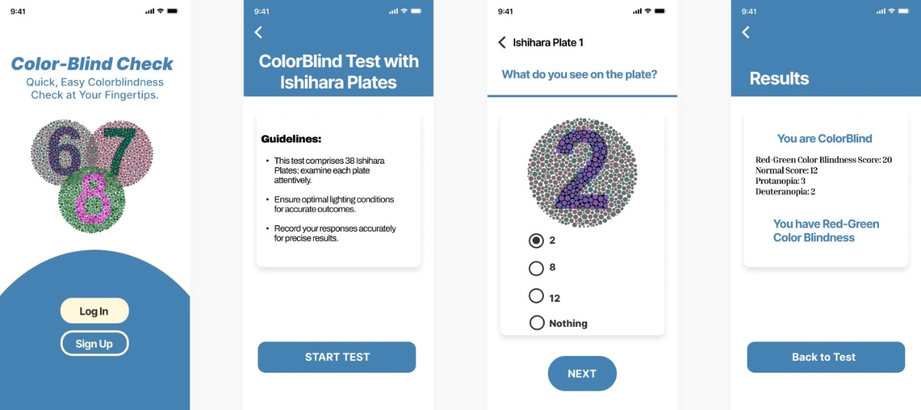

* **UI:**
* **Color Scheme:**

The color scheme is chosen with consideration for individuals with various types of color vision deficiencies. High contrast and distinguishable hues are employed to enhance readability and ensure that the UI elements are clearly visible to users with color vision impairments.

* **Intuitive Navigation:**

The application features a straightforward and intuitive navigation system. Clear icons, well-labeled buttons, and logical flow facilitate ease of use for users of all ages and technical proficiencies. The navigation structure is designed to guide users through the color vision tests with minimal effort.

* **Accessible Fonts and Typography:**

The use of accessible fonts and typography ensures that text elements are legible for users with visual impairments. Font sizes and styles are carefully chosen to enhance readability on various device screens.

* **Figma Prototype:**
  + **Home Screen:**

The home screen welcomes users with a clean layout, featuring a prominent "Start Test" button as the focal point. Clear and concise instructions guide users to initiate the color vision assessment.

* + **Testing Interface:**

The testing interface within the Figma prototype showcases the color vision tests in a user-friendly manner. Each test is presented on a distinct screen, and interactive elements allow users to respond seamlessly to prompts.

* + **Results Display:**

Upon completing a color vision test, users are directed to a results screen displaying a personalized report. The Figma prototype illustrates how the app visually communicates the type and severity of color blindness, ensuring that users can easily interpret and understand their results.

**Mockup:**

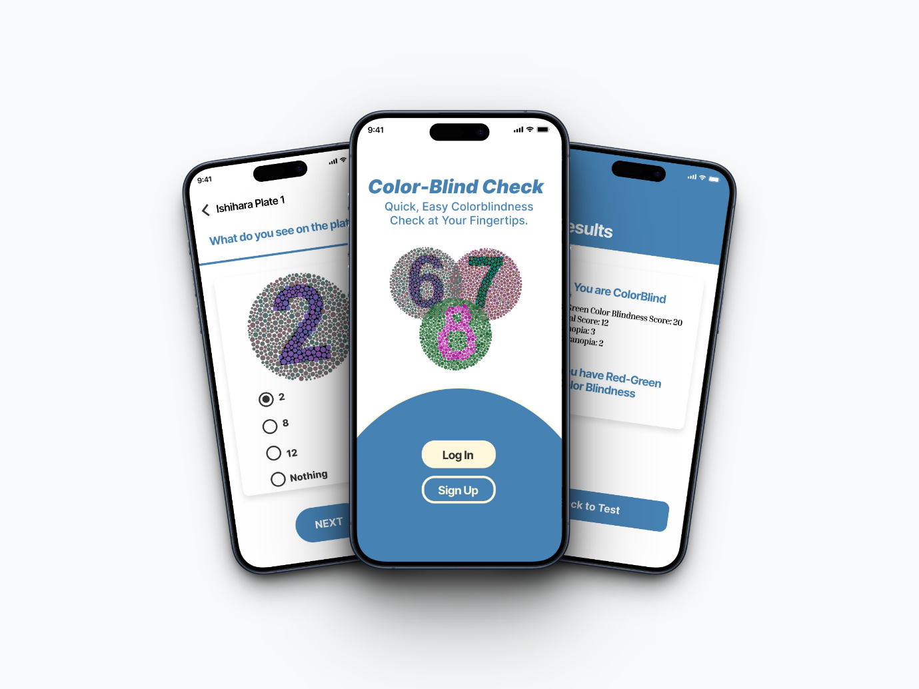

**System Architecture/DB:**

The mobile application will utilize a cross-platform development approach, employing Android Studio and Kotlin as the primary development frameworks. The backend system will be secure and scalable, handling user authentication, test data storage, and report generation

The mobile application for color blindness testing utilizes Firebase as the backend database, ensuring a secure and scalable infrastructure to handle user data, authentication, and report generation. The architecture is designed to be efficient, reliable, and capable of accommodating potential future expansions.

* **Cross-Platform Development:**

The decision to employ a cross-platform development approach using Android Studio and Kotlin is driven by the desire to ensure a consistent user experience across multiple platforms. Android Studio, with its robust set of tools allow for the creation of cross-platform applications using a single codebase. The use of Kotlin as the primary programming language further enhances code maintainability and readability, making it a suitable choice for Android development.

* **Backend System with Firebase:**

Firebase is selected as the backend database for its cloud-based services, providing a secure and scalable infrastructure. Firebase Authentication ensures that user data is protected, allowing users to create accounts and log in securely. The real-time database feature of Firebase facilitates efficient storage and retrieval of test data, ensuring a seamless and responsive user experience during color vision assessments.

* **Security Measures:**

The backend system is designed with security as a top priority. Firebase's authentication services employ industry-standard encryption protocols to safeguard user login credentials. Access controls and security rules are configured to restrict unauthorized access to sensitive data. Regular security audits and updates are planned to ensure the continued resilience of the system against potential threats.

* **Scalability Considerations:**

Firebase's scalability is leveraged to accommodate potential increases in user traffic and data storage requirements. As the user base grows, Firebase's cloud infrastructure can seamlessly handle additional load, maintaining optimal performance for color vision testing and report generation. This scalability ensures that the application can cater to a growing user community without compromising on responsiveness.

* **Efficient Data Handling:**

The efficient handling of user authentication, test data storage, and report generation is at the core of the backend architecture. Firebase's real-time database allows for quick and reliable storage of color vision test results. Data retrieval processes are optimized to provide users with immediate access to their personalized reports. Firebase Cloud Functions are employed for report generation, ensuring that the process is efficient and responsive.

**Test Case:**

* **User Authentication:**
  + Verify the creation of user accounts.
  + Test the login functionality.
  + Confirm the security measures for user authentication.
* **Diagnostic Testing:**
  + Validate the accuracy of color vision tests.
  + Test the identification of specific types and levels of color blindness.
  + Evaluate the consistency of test results over multiple sessions.
* **Progress Tracking:**
  + Confirm the functionality of the user profile system.
  + Test the tracking of changes in color vision over time.
  + Ensure accurate data recording and retrieval.
* **Accessibility Enhancements:**
  + Verify compatibility with screen readers.
  + Test the app's usability for individuals with disabilities.
  + Ensure adherence to accessibility standards.

**Technology Stack:**

* **Platform:** Cross-platform development for Android.
* **Development Frameworks:** Android Studio for efficient and consistent development. The app will be made with Kotlin, a language that's good for making things work smoothly on Android because it's easy to understand and works well with other code.
* **Backend:** Utilize a secure and scalable backend system to store user data and generate reports.

**Conclusion:**

This mobile application for color blindness testing represents a significant step towards making color vision assessments accessible and informative. By combining scientific accuracy, user-friendliness, and personalized reporting, the application contributes to improved understanding and management of color vision deficiencies. The intuitive design and robust testing methodologies ensure that the app can be widely adopted by both general users and healthcare professionals, fostering early detection and awareness in the broader population.